1. Login into zlp12222.vci.att.com server using your credentials



If you cannot see $ symbol hit enter one or two times, now you will get $ and ready to input commands

1. Now you must sudo to get privileged access

sudo su – brass

1. Confirm if you are inside **(/opt/app/brass)** home directory using below command

pwd



1. Create an empty (txt) file to put all your SID for performing retrigger operation.

vi <name of your file>.txt

(this will open the empty txt file for you to input detail as below)

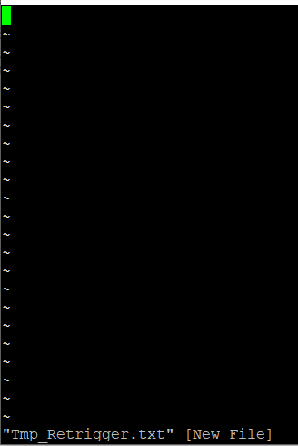

* Press “I” to get into insert mode (In insert mode you can edit data inside the text document)
* Enter/Paste your SID now. Make sure you are entering the one SID per line like below.

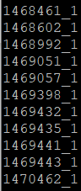

* Now to save and exit type

:wq!



If you don’t want to save and exit type

:q!



1. Now you must run the below command to start retriggering.

**NOTE**: Replace filename with your text file name

for i in $(cat filename)  
do  
/opt/app/brass/bin/processPSUQ.pl -p Clarify -d Clarify -n ${i} -t update_status -f  
done

1. **Now your orders will start getting retriggered one by once, and you can see it on screen (Successful). If any order fails, you will get some other message then go and check it manually in GUI.**

**Created by Saravanan**